Explore & Understand SOAP API by Postman

Learning Objectives
- Explore WSDL file of a SOAP API
- Learn how to import a WSDL file into Postman
- Learn how to make a SOAP request in Postman
There are still many APIs running on the older SOAP (Simple Object Access Protocol). Unless your organization is brand-new, chances are you’re developing and maintaining legacy codebases that rely on SOAP.

Explore WSDL file

Use a text editor to explore and understand the structure of WSDL files as following:
WSDL file: http://www.dneonline.com/calculator.asmx?WSDL
WSDL file: https://www.w3schools.com/xml/tempconvert.asmx

Import WSDL into Postman
WSDL file: http://www.dneonline.com/calculator.asmx?WSDL
Open Postman and click on Import > Link and paste the link to the WSDL file. Click on Continue.
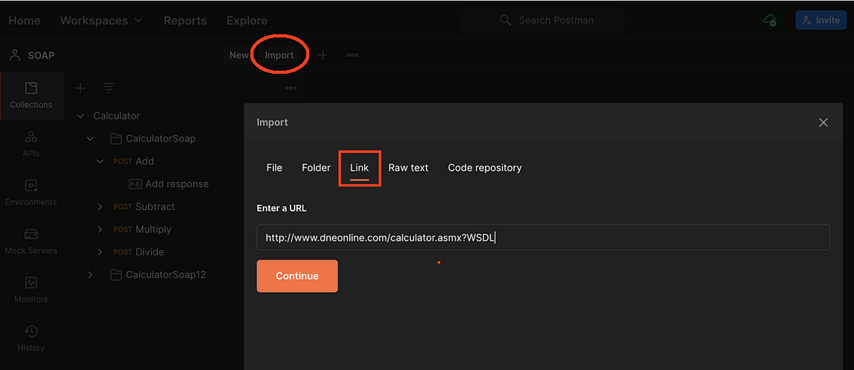
Finally, click on Import.
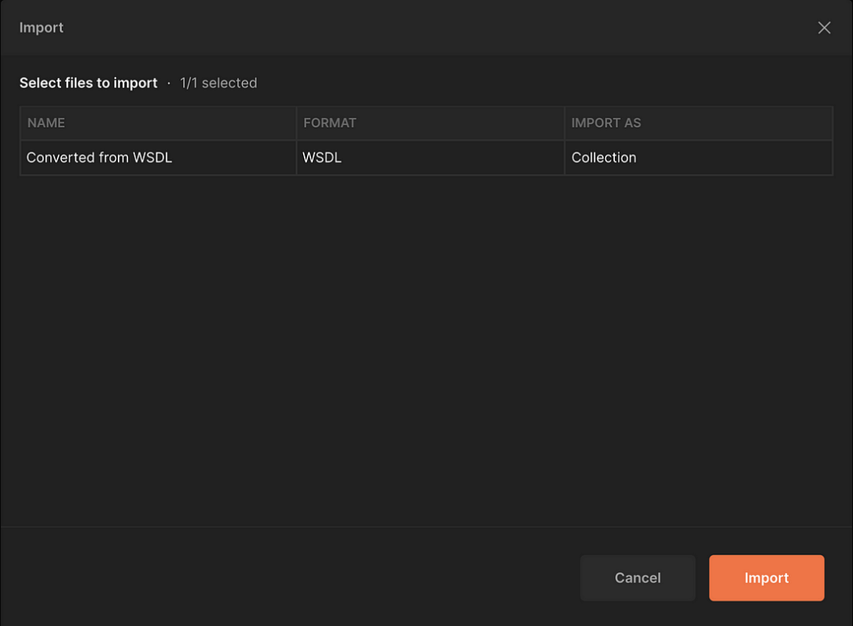
The collection will be added to your existing Postman collections. Feel free to rename it as needed.
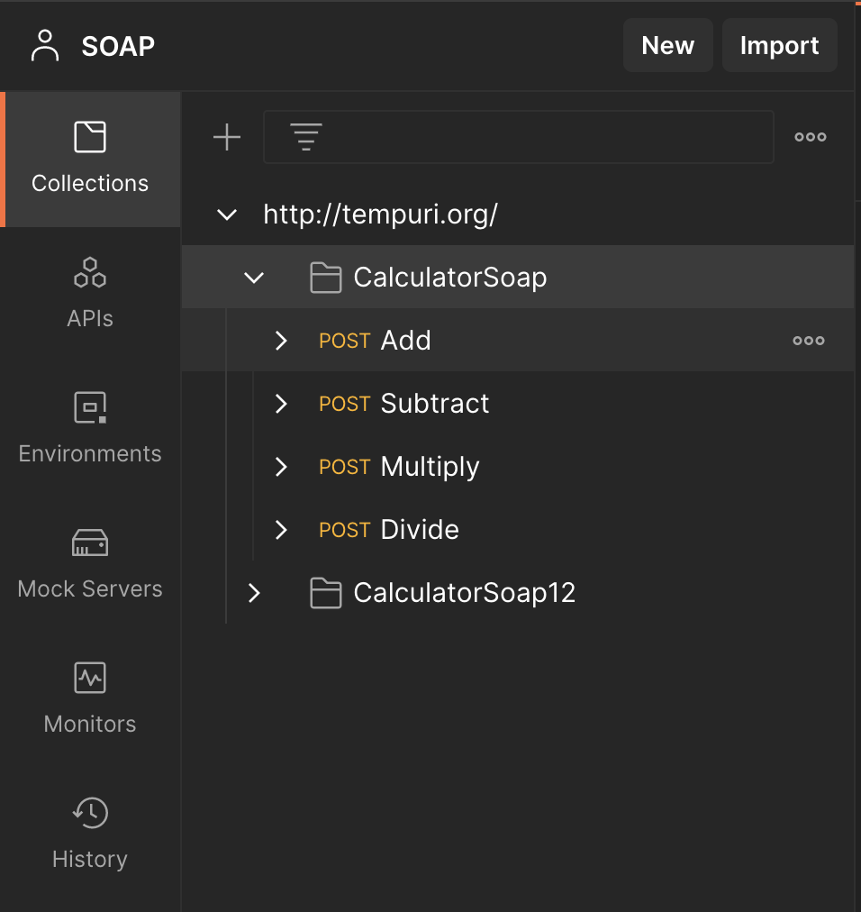

Making SOAP Requests with Postman
WSDL file: https://www.w3schools.com/xml/tempconvert.asmx
Here’s how you can use Postman for making SOAP requests:
- Enter the SOAP endpoint as the request URL in Postman:
https://www.w3schools.com/xml/tempconvert.asmx
- Set the request method to POST.
- Under the Body tab, set the body type to raw and select XML from the dropdown. Once you add XML data as the body, Postman will automatically add a Content-Type header that can be seen under the Headers tab. While REST typically uses JSON and other data formats, SOAP relies on XML.
- Under the Headers tab, add a new header where Content-Type is the key and text/xml is the value in order to override the one added for you in the previous step, since the endpoint we’re working with requires a different Content-Type header. You can deselect the originally added header.
- Back in the request body under the Body tab, define the SOAP envelope, body, and header tags. Start with the required SOAP envelope tag and define all the namespaces. Enter the SOAP body and headers. The name of the SOAP method (operation) should be specified in the SOAP body, as seen in the code block below. Then hit Send, and inspect the response.
<soap12:Envelope xmlns:xsi="http://www.w3.org/2001/XMLSchema-instance" xmlns:xsd="http://www.w3.org/2001/XMLSchema" xmlns:soap12="http://www.w3.org/2003/05/soap-envelope">
<soap12:Body>
<FahrenheitToCelsius xmlns="https://www.w3schools.com/xml/">
<Fahrenheit>75</Fahrenheit>
</FahrenheitToCelsius>
</soap12:Body>
</soap12:Envelope>
This example uses a temperature conversion service to convert 75 degrees Fahrenheit to Celsius. Try it out in the example template SOAP: Fahrenheit to Celsius conversion:

If you’re a genius who can already do this conversion in your head, then check out this collection of other public SOAP APIs to mess around with.
And there you have it! Postman is a trusty tool to handle any API that can utilize HTTP—like REST, SOAP, and GraphQL.

